CP4282 Assignment #3 **Due Tuesday June 25th** ( 25 marks total )

For this assignment you will modify your solution to assignment #2 to include navigation and an additional page where you can modify the data for your top 3 list.

Please note that if your Assignment #2 is not in a condition to continue working on, Eric will provide a clean solution during class and place on GitHub which you can start with.

At this point you will have the following application which functions as shown below:

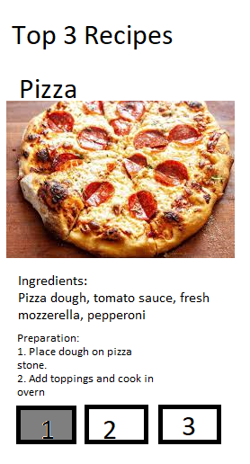

You will modify this main screen which displays your top 3 list to include navigation buttons where you can navigate between the top3 list and a page where you can edit the data:

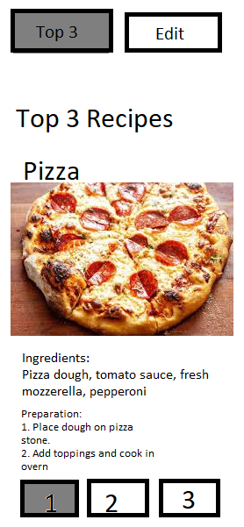

The page to Edit the top 3 list should include the two navigation buttons and should include textInput components and a button as shown below:

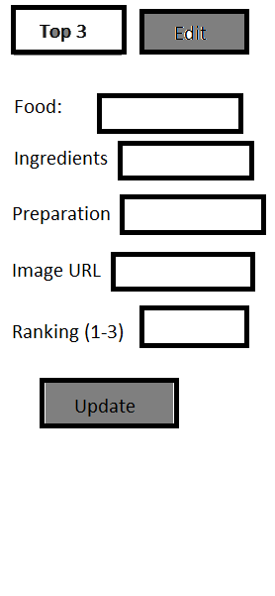

Requirements:

1. ( 2 marks) Continue working on your Assignment #2 repo, or fork Eric’s repo with the Assignment #2 solution. **Ensure that the repository is private**. You can make it public after I have finished marking.
2. (3 marks) Modify your project to use expo router. This was demoed in class Thurs June 6th: <https://docs.expo.dev/router/installation/#manual-installation>
3. (5 marks) Setup a basic naviation with two pages. One page for the top 3 display and one for editing the list. Note, you may want to test the navigation by running in the browser as at this point you won’t have navigation buttons. You will want to create a layout route which uses the ‘Slot’ component. <https://docs.expo.dev/router/layouts/>
4. (5 marks) Setup the React Context API to share data between both pages. This was demoed in class Fri June 7th.   
   <https://www.freecodecamp.org/news/context-api-in-react/>

<https://github.com/EricStockTeacher/ReactNativeDemo>

1. (3 marks) Create a ‘NavBar’ component which includes the two buttons to move between the pages. Ensure this component is placed in the layout route. (This was demoed in class on Fri June 7th)
2. (7 marks) Hook up the functionality of updating the top 3 list from the “Edit” page and then be able to view the changes on the “View” page. **You will need to use web URL’s to display your images**.